**CASE STUDY**

Created a NGINX app consisting:-

* Pods
* Deployments
* Rcs/Rs
* Volumes
* Secrets
* Persistent Volume Claim

**Approach:-**

* To eradicate difficulty in scaling and adapting to the growing online audience,deployment and replication controller is used to scale up according to the need.

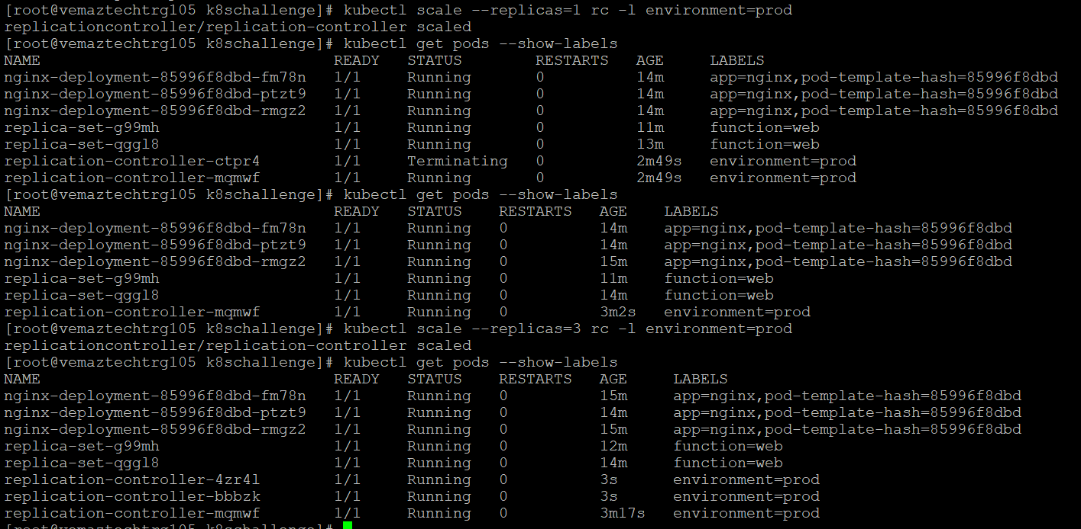

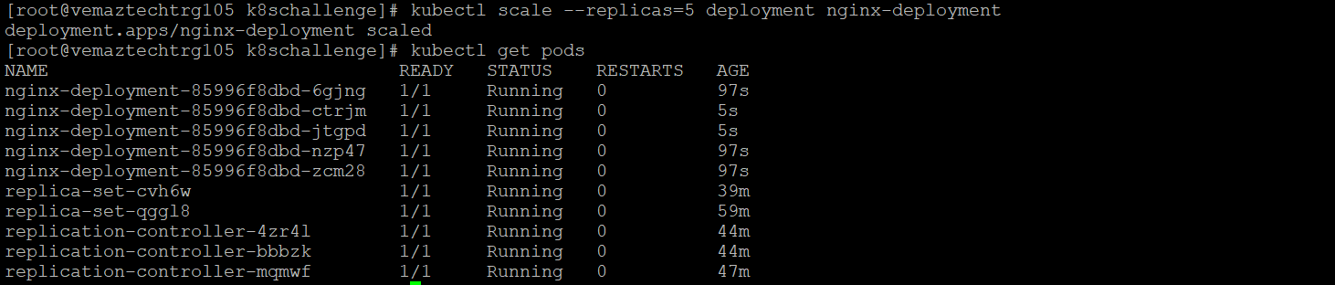

(other screenshots are attached in screenshot folder)

* To build and deliver content primarily over the web,service is used containing port,nodeport and target port.The same port is used in Deployment in mapping container.

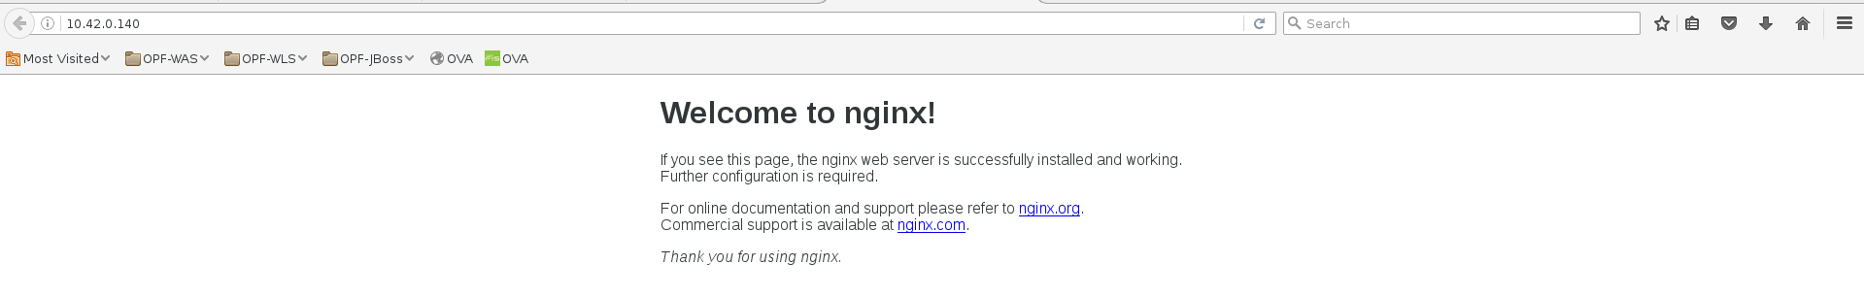

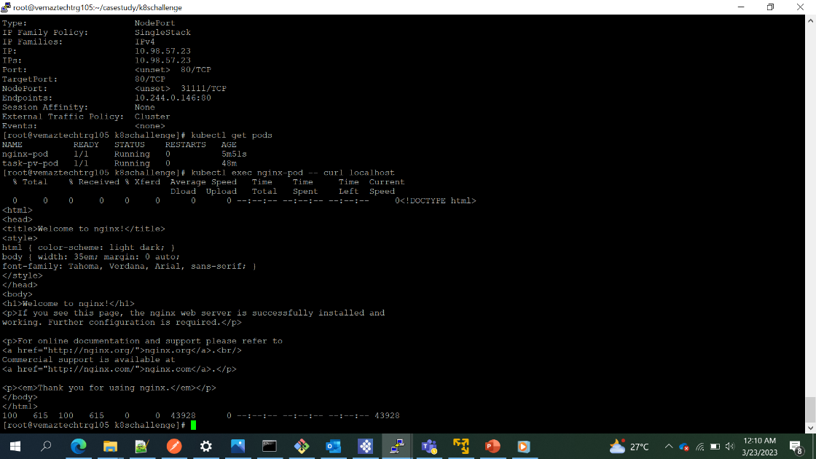

* To upgrade a version. But the release wasn’t verified an environment which matches Production. So expect roll back of release. Deployment can easily solve this. WE can upgrade to any version of the image we need and also rollback to previous versions too.

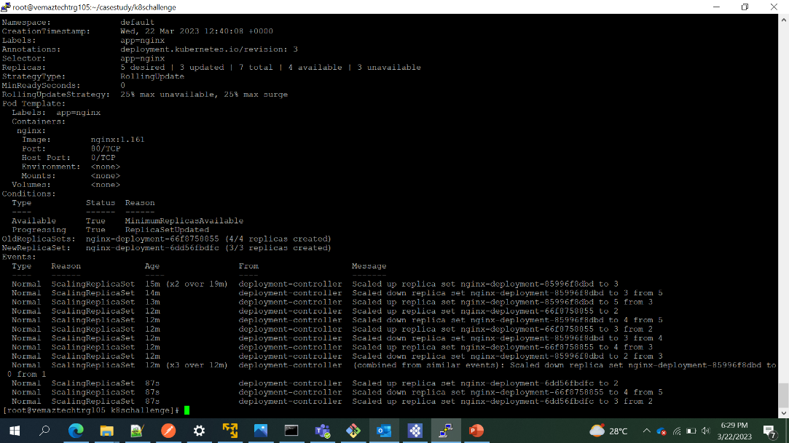

* To build an stateful apps using this new infrastructure,we have use persistent volume claim.

